**Kontakkt School ERP Dashboard User Guide**

**Introduction**  
Welcome to the Kontakkt School ERP Dashboard! This guide will help you navigate and utilize the various features and tools available on the dashboard.

**Accessing the Dashboard**

**Q: How do I log in to the dashboard?**  
**A: Click on Login Page Section**

* Go to the Kontakkt School ERP login page.
* Enter your username and password.
* Click on the "Login" button to access the dashboard.

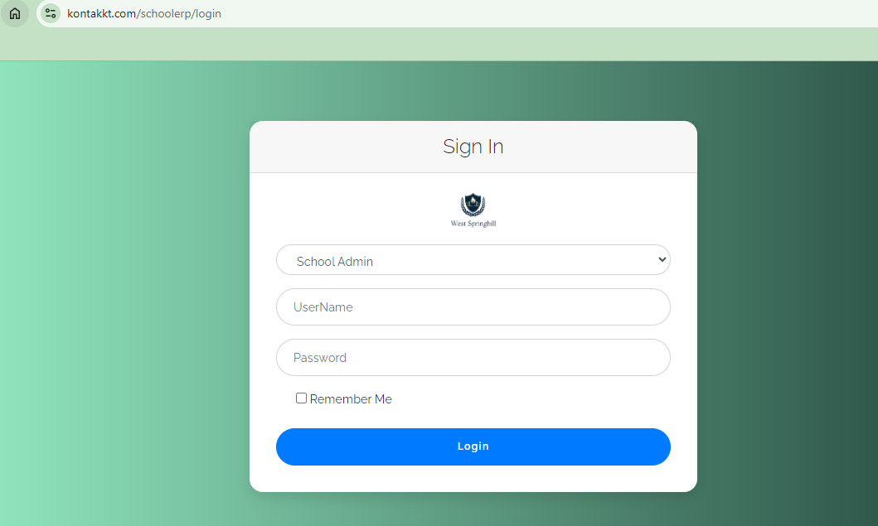

**Dashboard Overview**

**Q: What will I see upon logging in?**  
**A:** Upon logging in, you will be greeted with the main dashboard interface, divided into several sections.

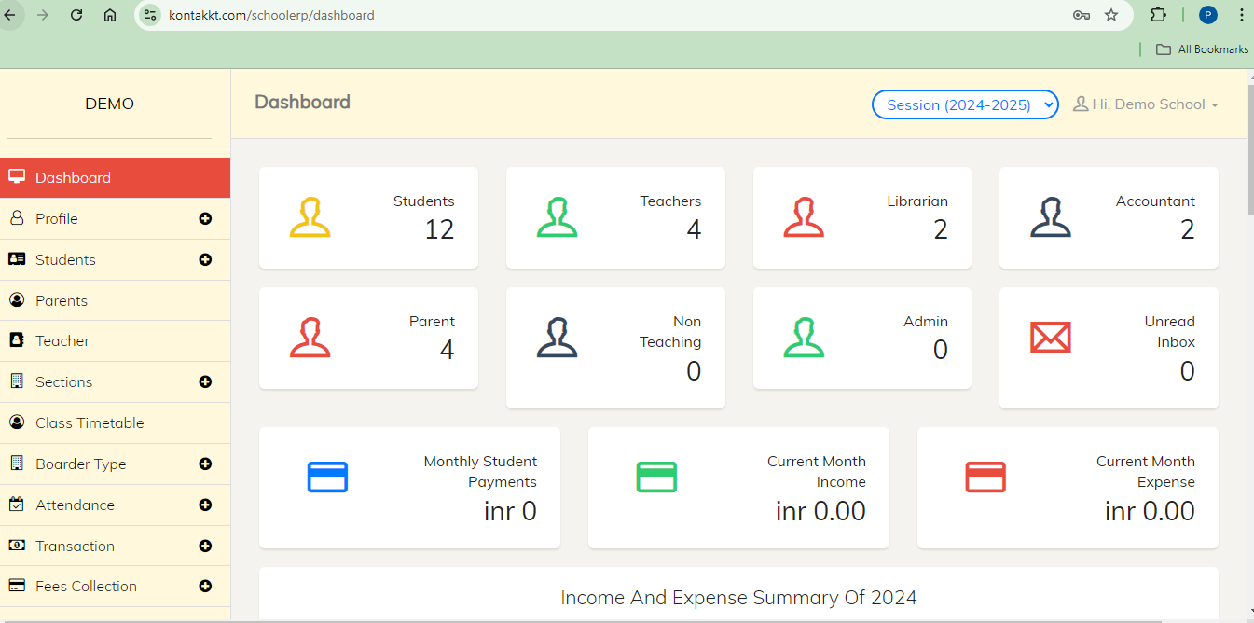

**Q: What is in the navigation menu?**  
**A:** The navigation menu, located on the left side, provides quick access to different modules and features:

* **Home**: Returns you to the main dashboard view.



* **Students**: Manage student information, including enrollment, attendance, and academic records.

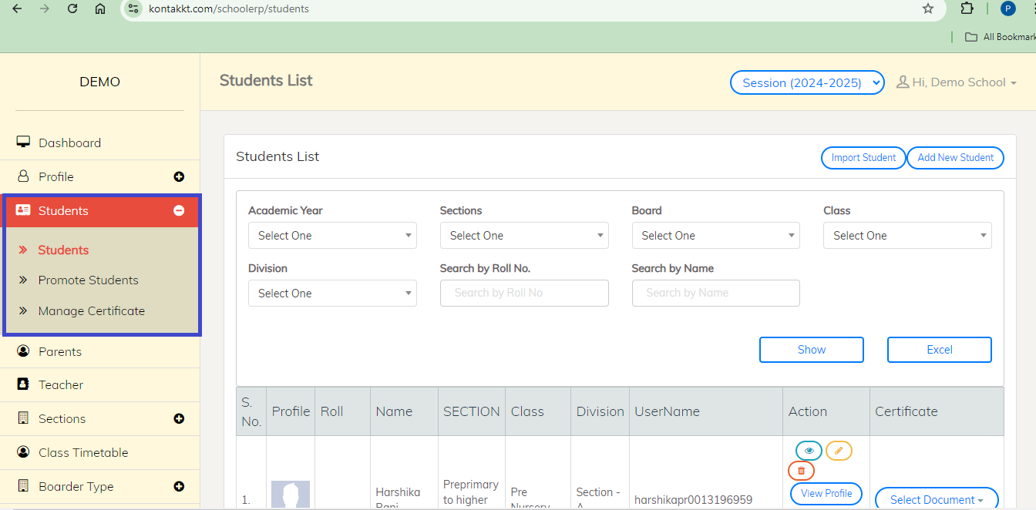

* **Teachers**: Manage teacher information and schedules.

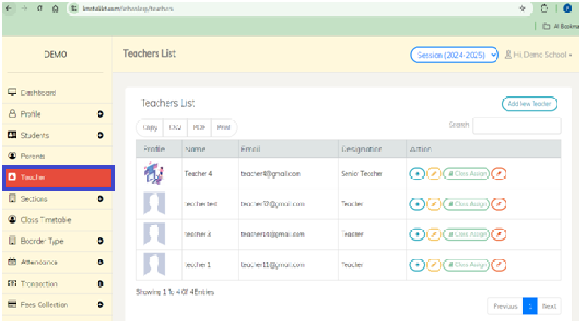

* **Classes**: View and manage class schedules and assignments.

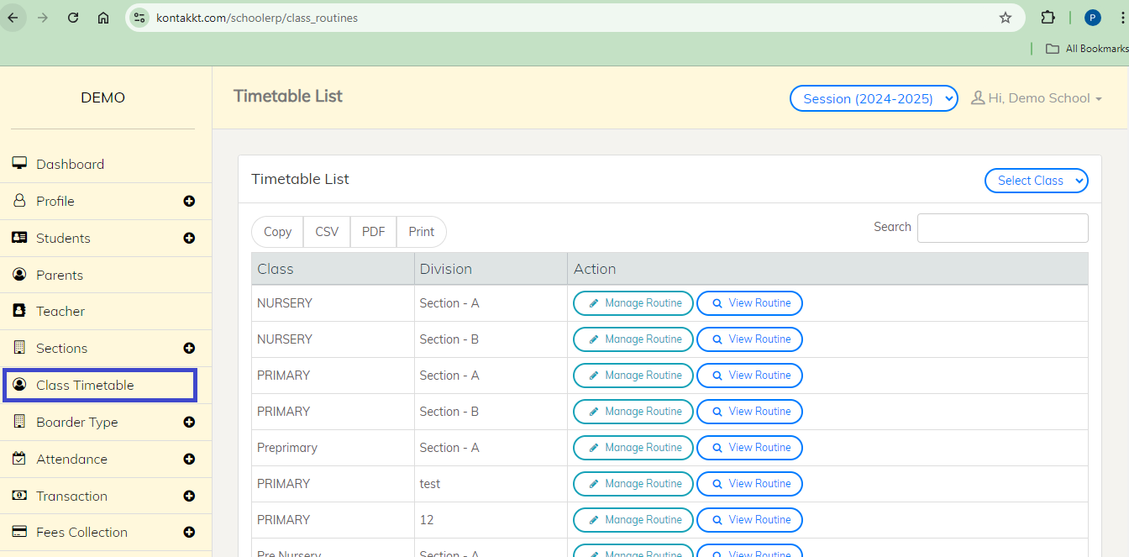

* **Fees**: Manage fee structures, payments, and receipts.

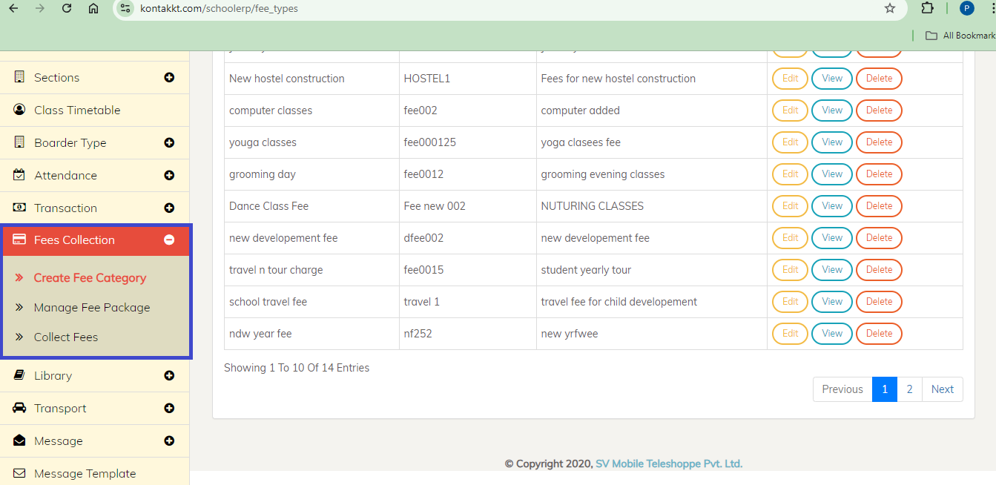

* **Library**: Manage library resources and transactions.

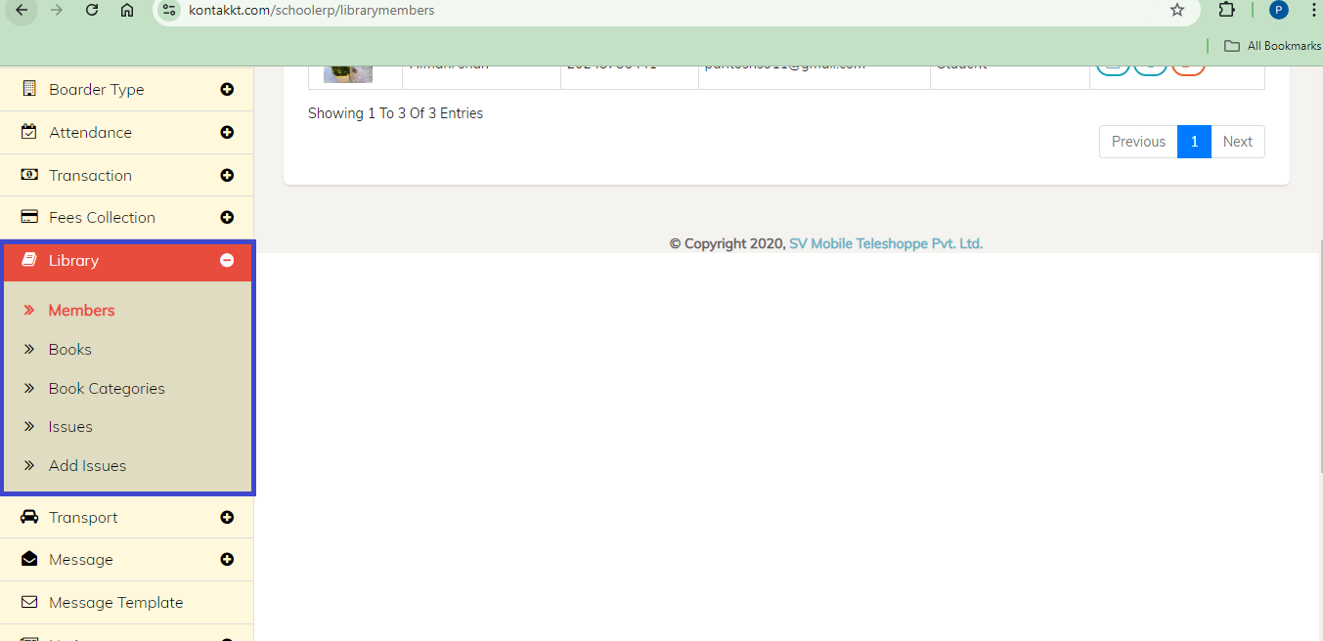

* **Transport**: Manage transportation routes and schedules.

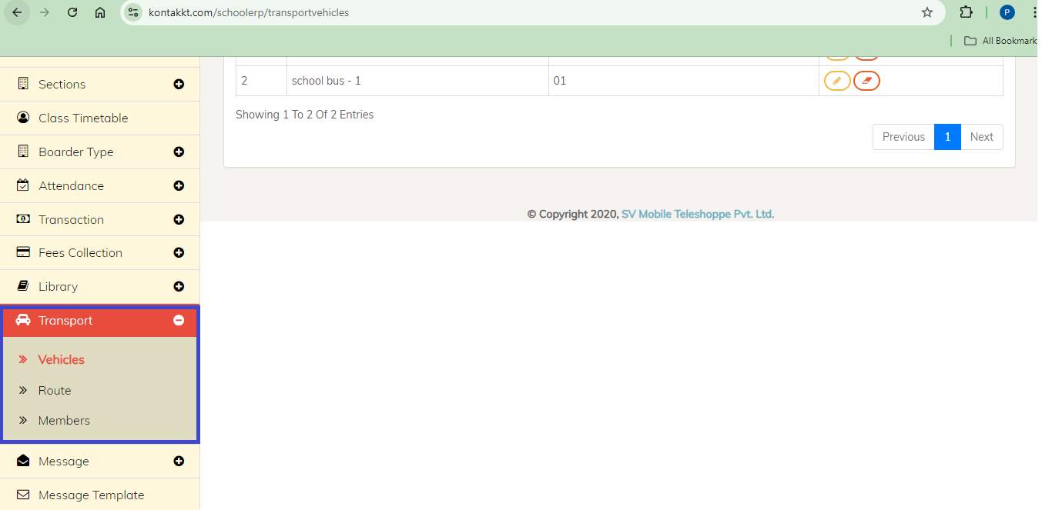

* **Reports**: Generate various reports related to students, teachers, and school activities.

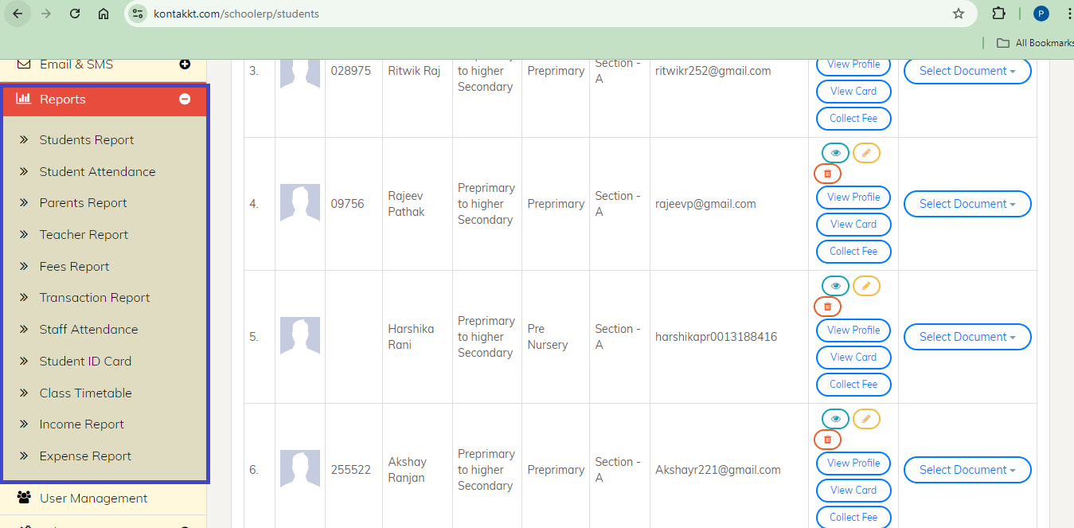

* **Settings**: Customize the system settings according to your school's needs.

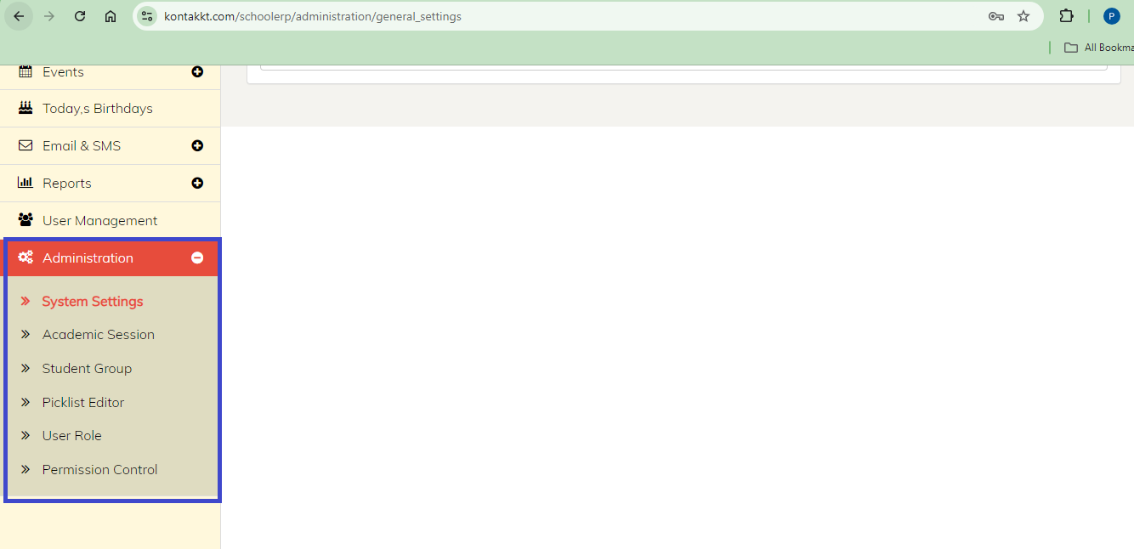

**Q: What is displayed in the main dashboard area?**  
**A:** The central part of the dashboard displays an overview of key metrics and recent activities:

* **Statistics**: Quick stats on the number of students, teachers, classes, etc.
* **Recent Activities**: Latest updates and activities within the system.
* **Notifications**: Important notifications and alerts.



**Q: What can I access from the top bar?**  
**A:** The top bar provides quick access to user profile settings, notifications, and help:

* **User Profile**: Click to view and edit your profile information.
* **Change Password**: Click to change your passwords..
* **Logout**: Click to logout from the application
* **Session:** Click to select the session.

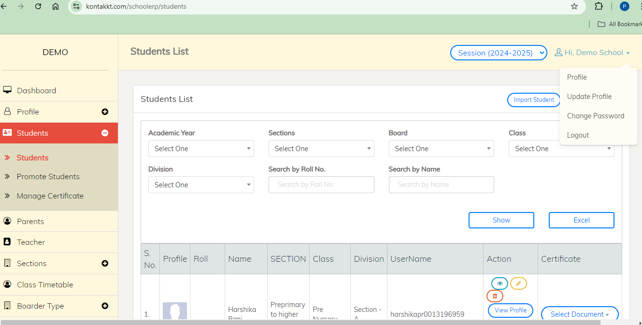

**Using the Dashboard Features**

**Q: How do I manage students?**  
**A: Click on Students Section**

* **Add New Student**: Navigate to "Students"

1. "Add Student" and fill in the required details.

* **View/Edit Student Information**: Navigate to "Students"

1. "Student List", select a student
2. Click "Edit" to update their information.

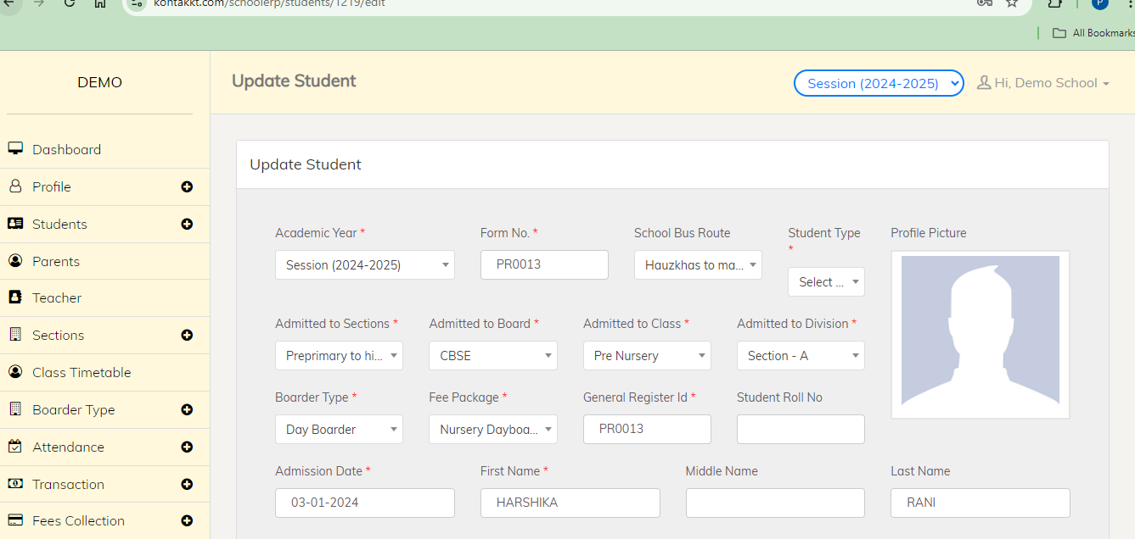

**Q: How do I promote students?**  
**A: Click on Students Section**

1. Click on "Promote Students"
2. Select the required fields
3. Click on “Next”

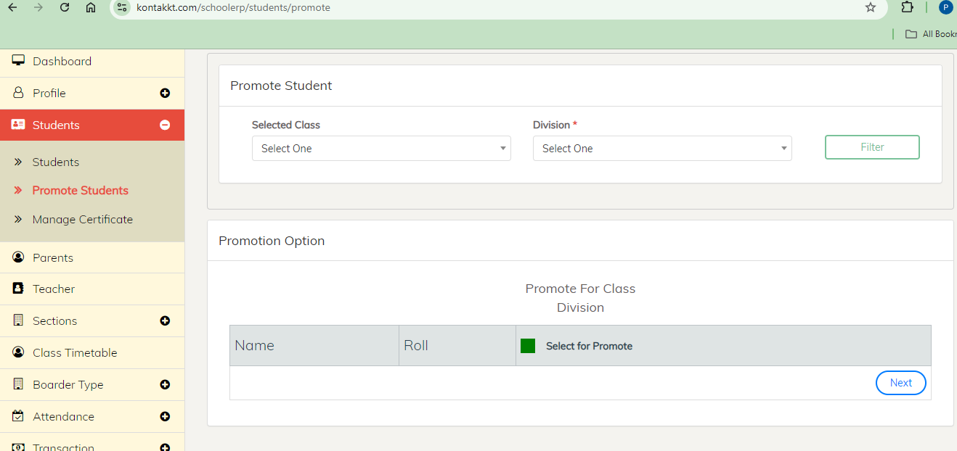

**Q: How do I manage certificates?**  
**A: Click on Students Section**

1. Click on "Manage Certificate"
2. Select the required fields
3. Click on “Select Document”
4. Click on “Print card”

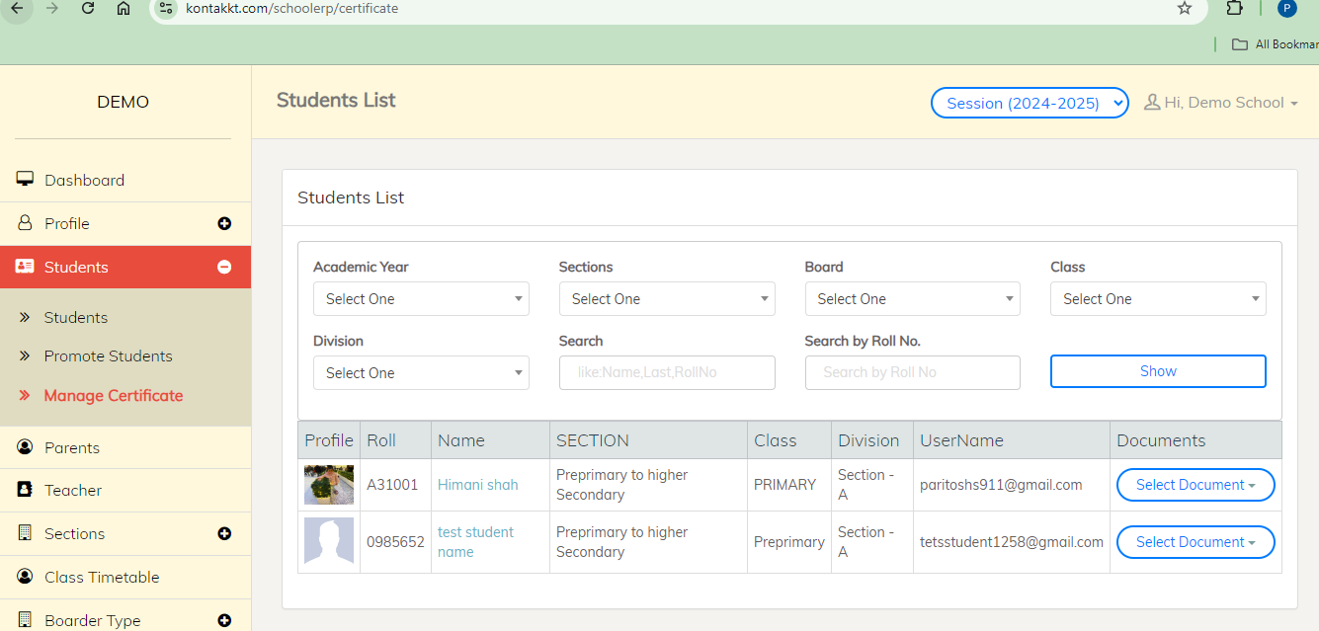

**Q: How do I manage teachers?**  
**A: Click on Teachers Section**

* **Add New Teacher**:

1. Navigate to "Teachers"
2. Click on "Add Teacher"
3. Fill in the required details.
4. Click on Add Teacher

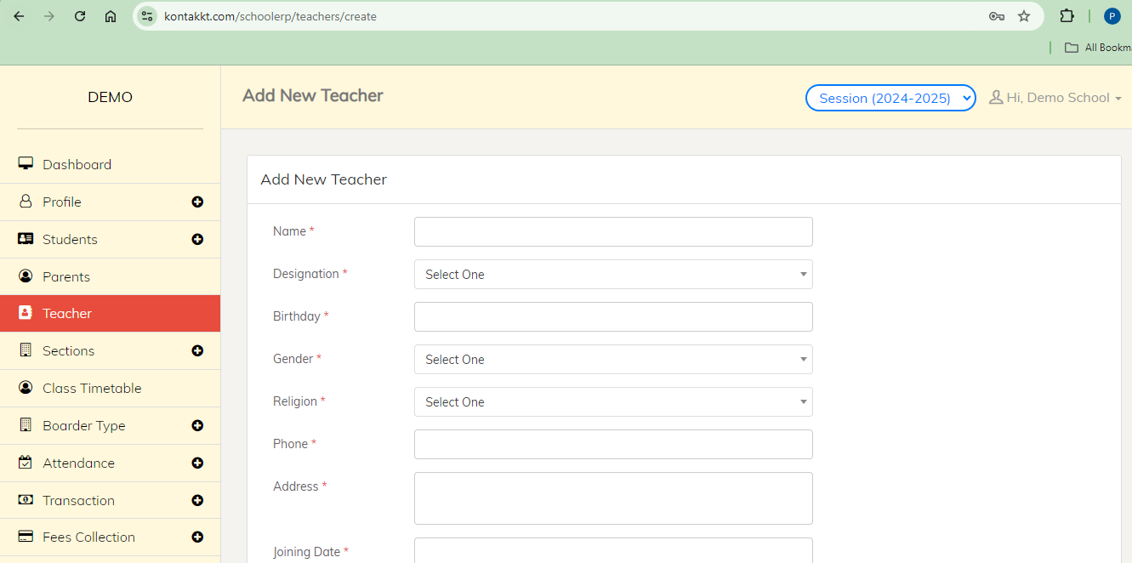

* **View/Edit Teacher Information**:

1. Navigate to "Teachers"
2. Go to "Teacher List"
3. Select a teacher
4. Click "Edit" to update their information.
5. Click “Update Teacher”

* **Schedule**:

1. Click on "Class Assign"
2. Select the required fields
3. Click on “Submit”

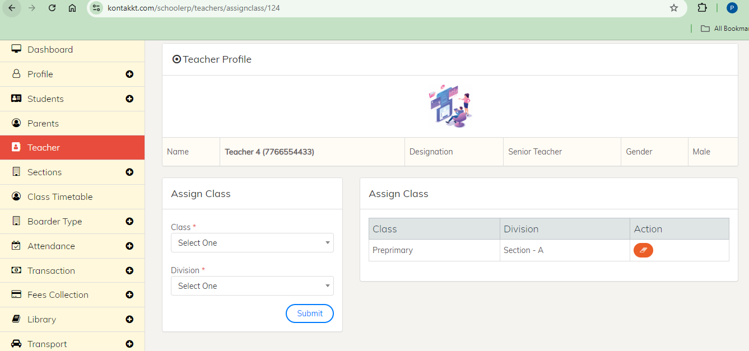

**Q: How do I manage classes?**  
**A: Click on Class Timetable section**

1. Click on “Manage Routine”

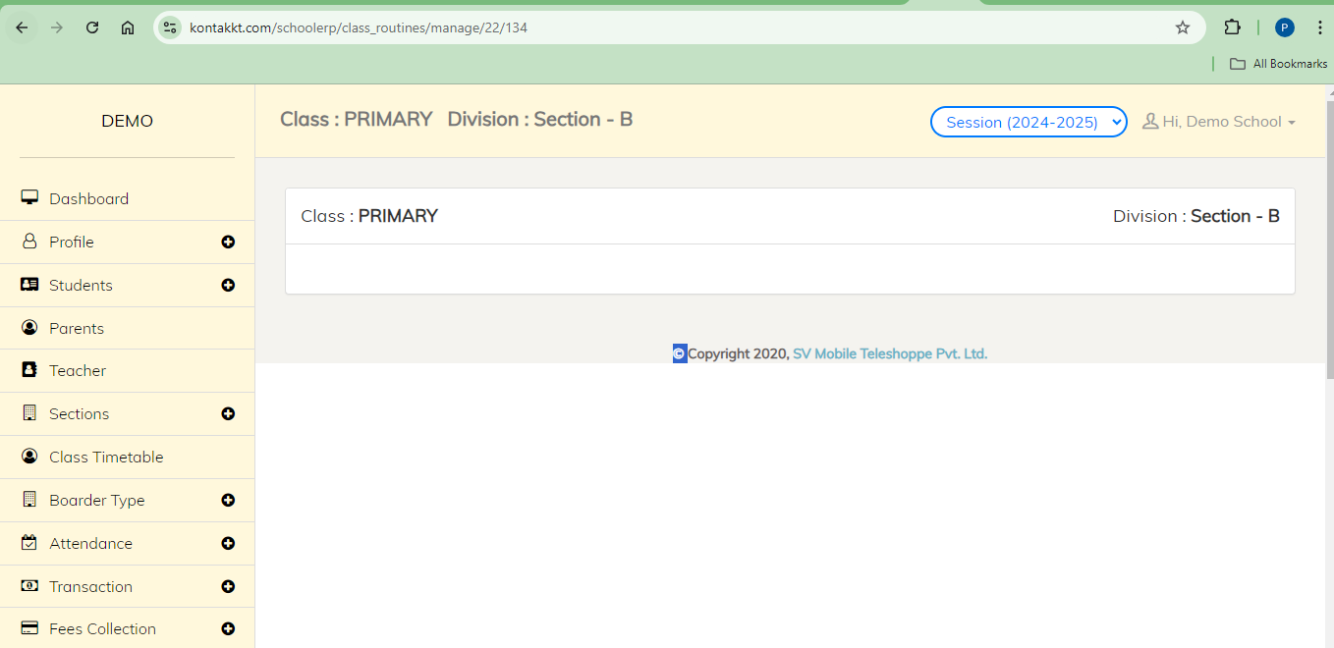

**Q: How do I manage fees?**  
**A: Click on Fees Collection section**

* **Set Fee Category**

1. Click on Create Fee Category
2. Click on “Add New”
3. Fill the required details
4. Save

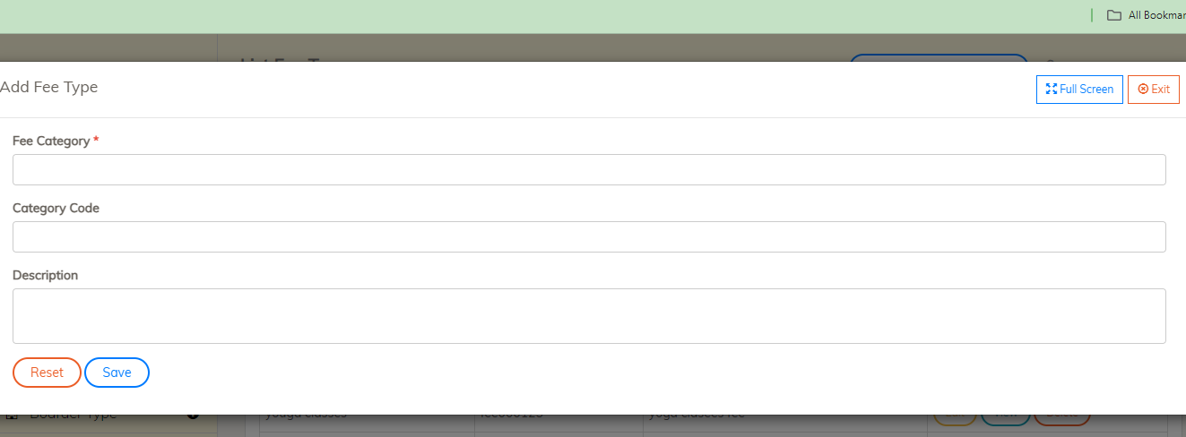

* **Set Fee Payments**:

1. Click on “Manage Fee Package”
2. Click on “Add New”
3. Fill the required details
4. Save

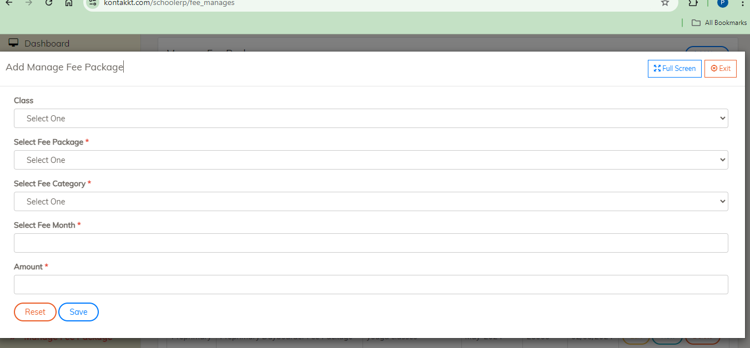

* **Collect Fees**:

1. Click on “Collect Fees”
2. Fill the required details
3. Click on “Show Student”
4. Select Student
5. Click on “Collect Fees”
6. Click on “Fee Pay”
7. Fill the required details
8. Save

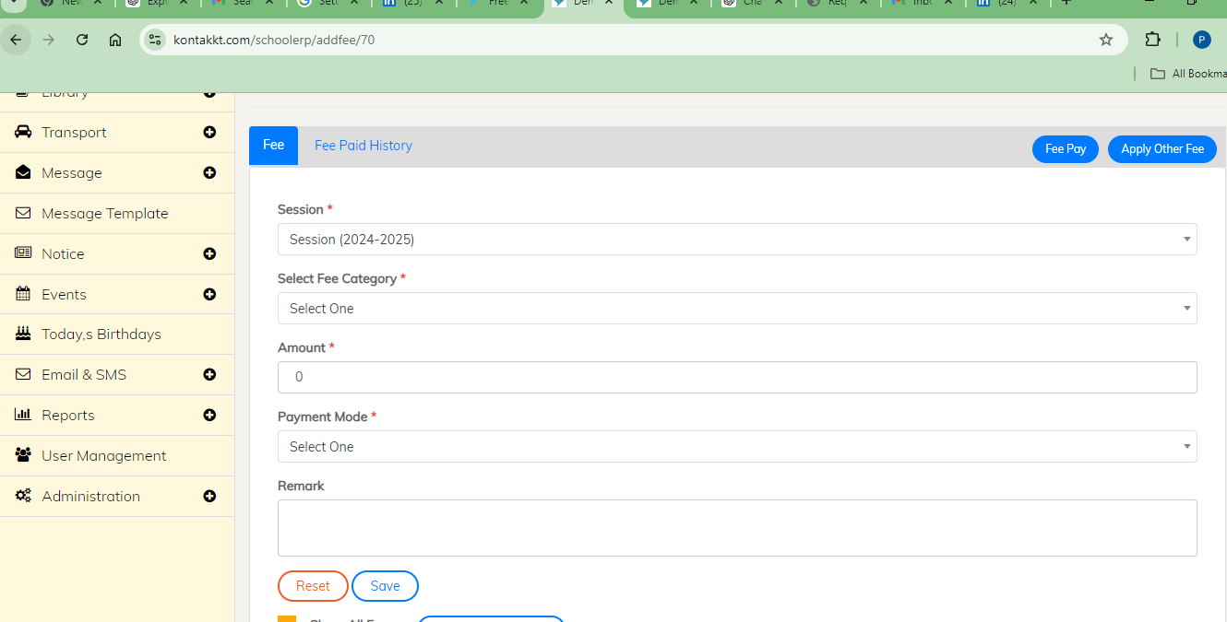

**Q: How do I manage library resources?**  
**A: Click on Library section**

* **Add Books**:

1. Click on “Books”
2. Click on “Add New Book”
3. Fill the required details
4. Click on “Add Book”

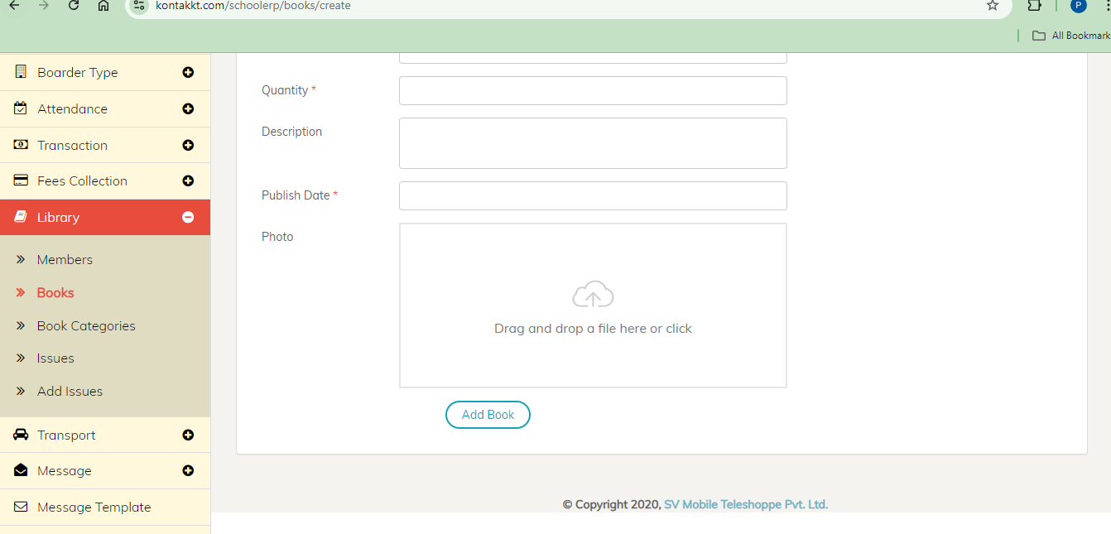

* **Issue/Return Books**

1. Click on “Issues”
2. Select “Library Id”
3. Click on “Search”

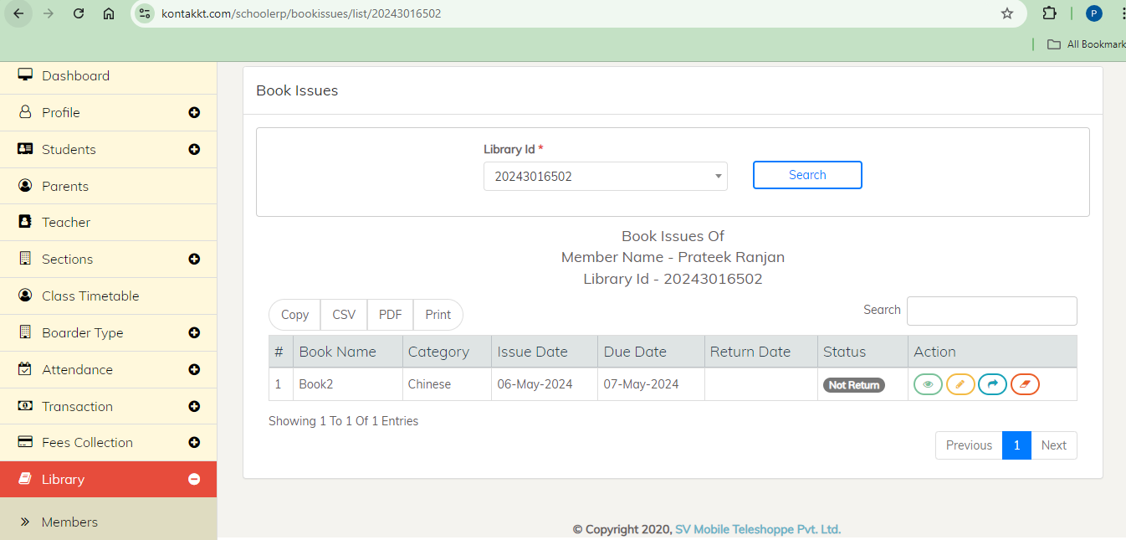

* **Add Member**:

1. Click on “Add New Member”
2. Fill the required details
3. Click on “Add Member”

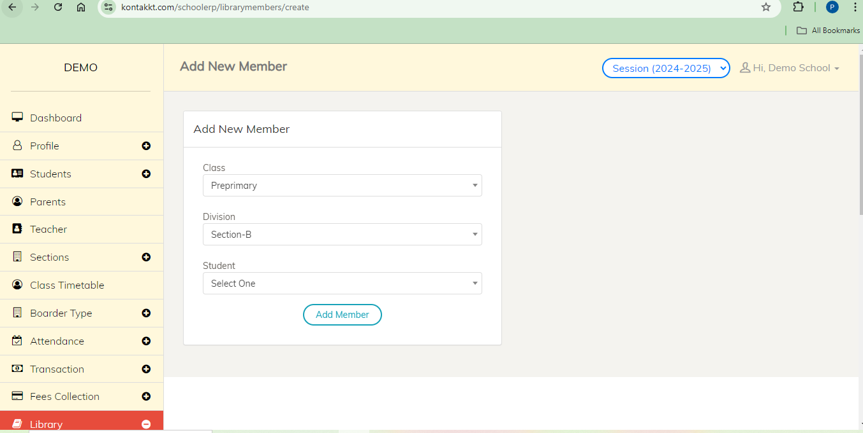

* **Add Issues**:

1. Click on “**Add Issues**”
2. Fill the required details
3. Click on “Add Issue”

**Q: How do I manage transport?**  
**A: Click on Transport Section**

* **Add Routes**

1. Click on “Route”
2. Click on “Add New Route”
3. Fill the required details
4. Click on “Add Transport”

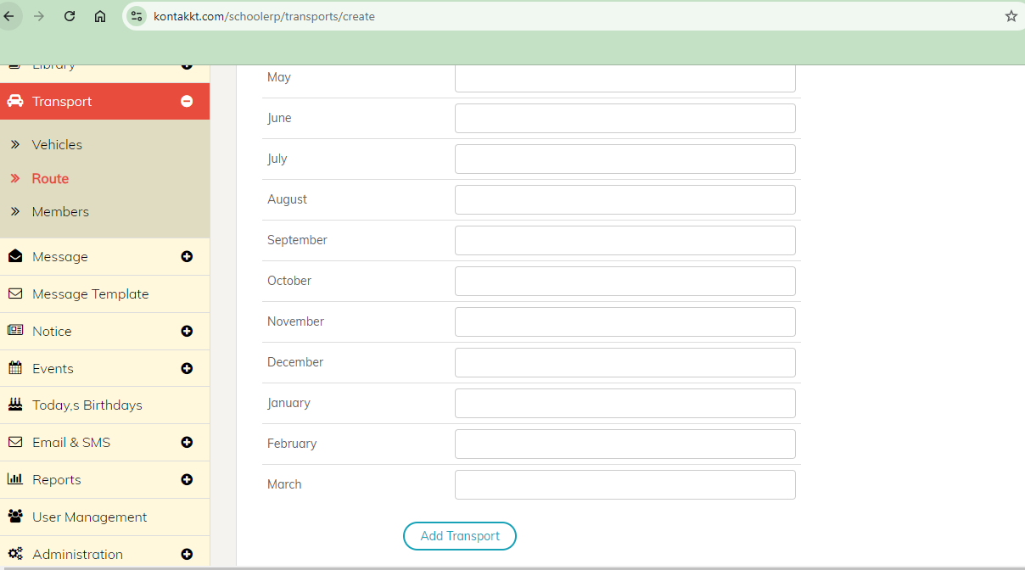

**Q: How do I assign routes?**  
**A: Click on Transport Section**

1. Click on “Members”
2. Click on “Add New Member”
3. Fill the required details
4. Click on “Add Member”

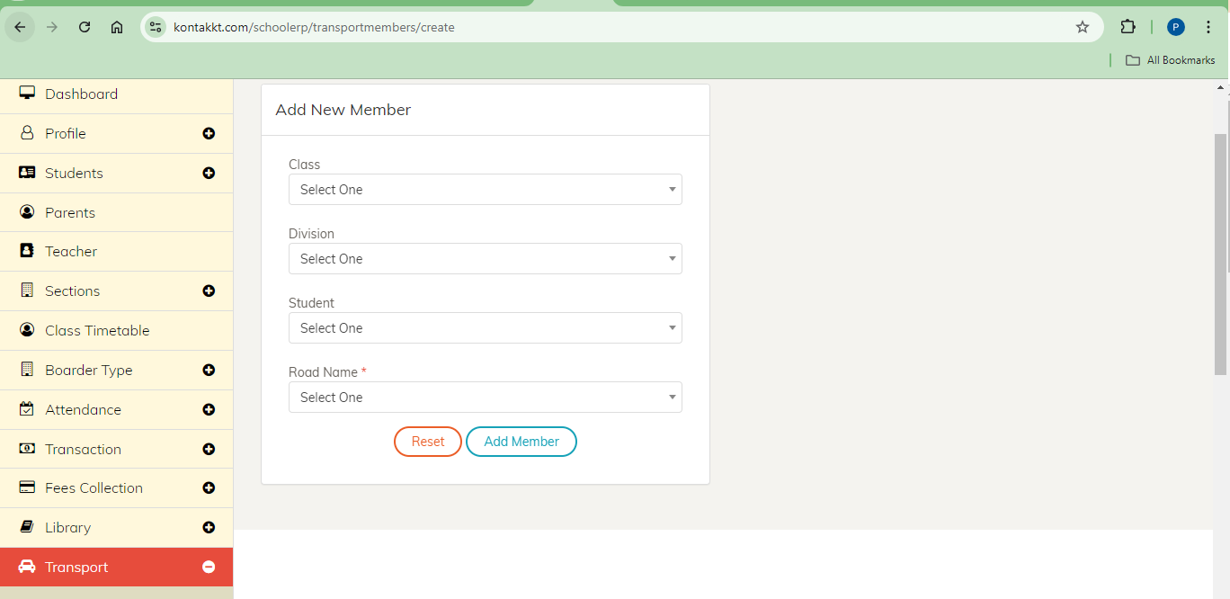

**Q: How do I add vehicles?**  
**A: Click on Transport Section**

1. Click on “Vehicle”
2. Click on “Add New Vehicle”
3. Fill the required details
4. Click on “Add Vehicle”

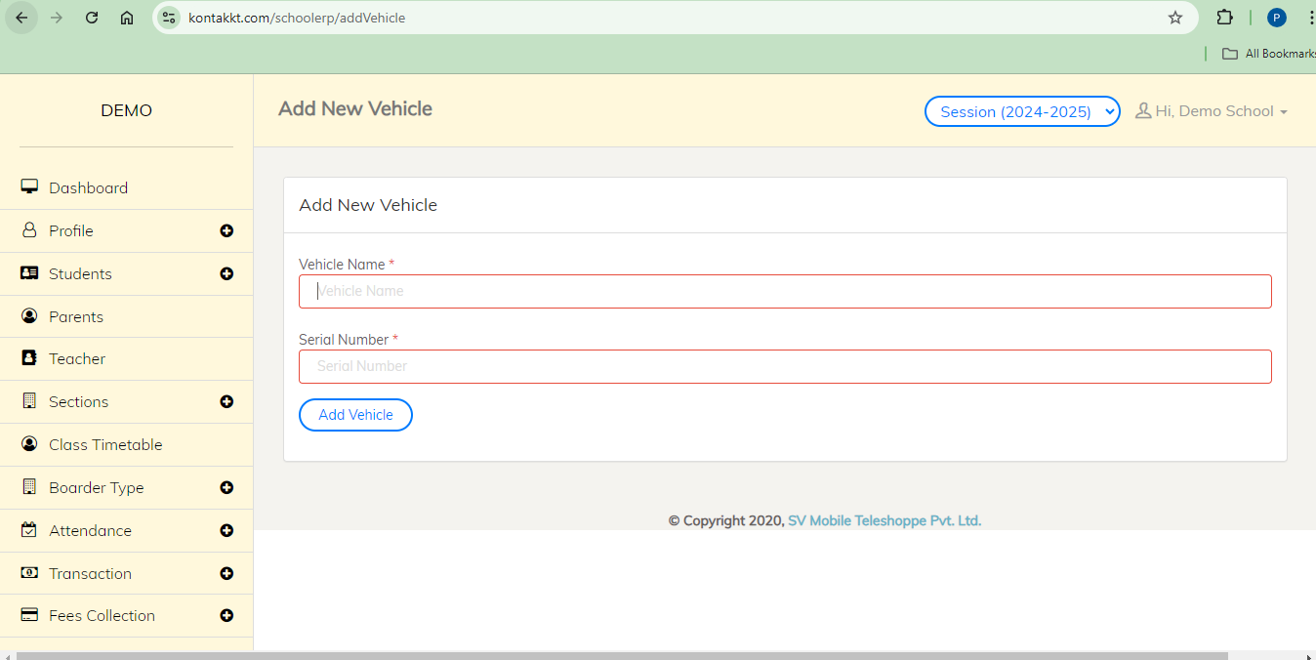

**Q: How do I generate reports?**  
**A: Click on Reports section**

1. Click on “Reports”
2. Select the report you need.
3. Fill the required details
4. Click on “Show”

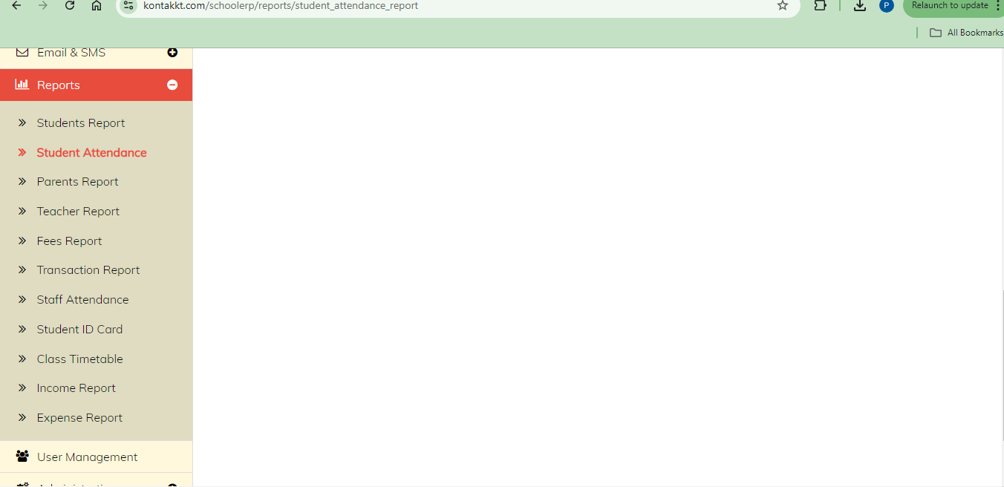

**Q: How do I customize settings?**  
**A: Click on Administration Section**

* **System Settings setup**

1. Click on “System Settings”
2. Customize the system settings according to your preferences.
3. Click on “Save Settings”

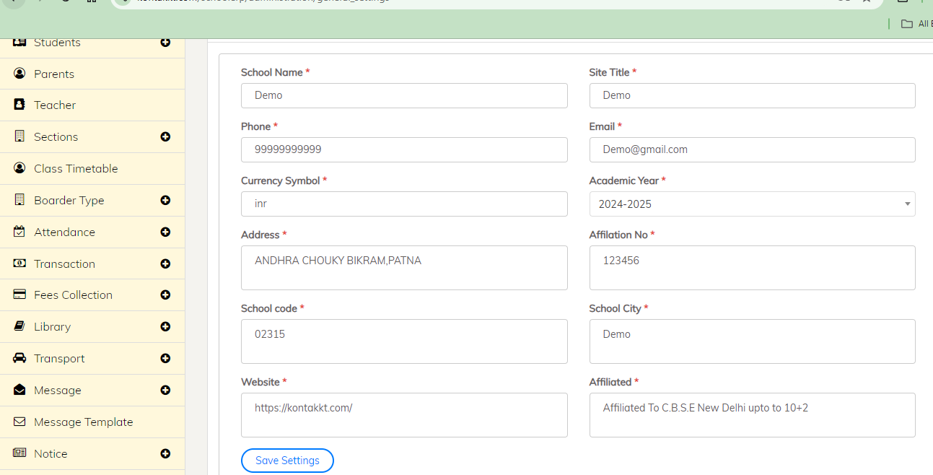

**Q: How do I add** **Academic Session?**  
**A: Click on Administration Section**

1. Click on “Academic Session”
2. Click on “Add New”
3. Fill required details
4. Click on “Save”

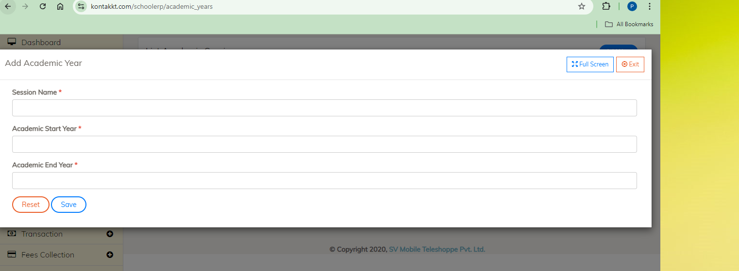

**Q: How do I add** **Student Group?**  
**A: Click on Administration Section**

1. Click on “Student Group”
2. Click on “Add New”
3. Fill required details
4. Click on “Save

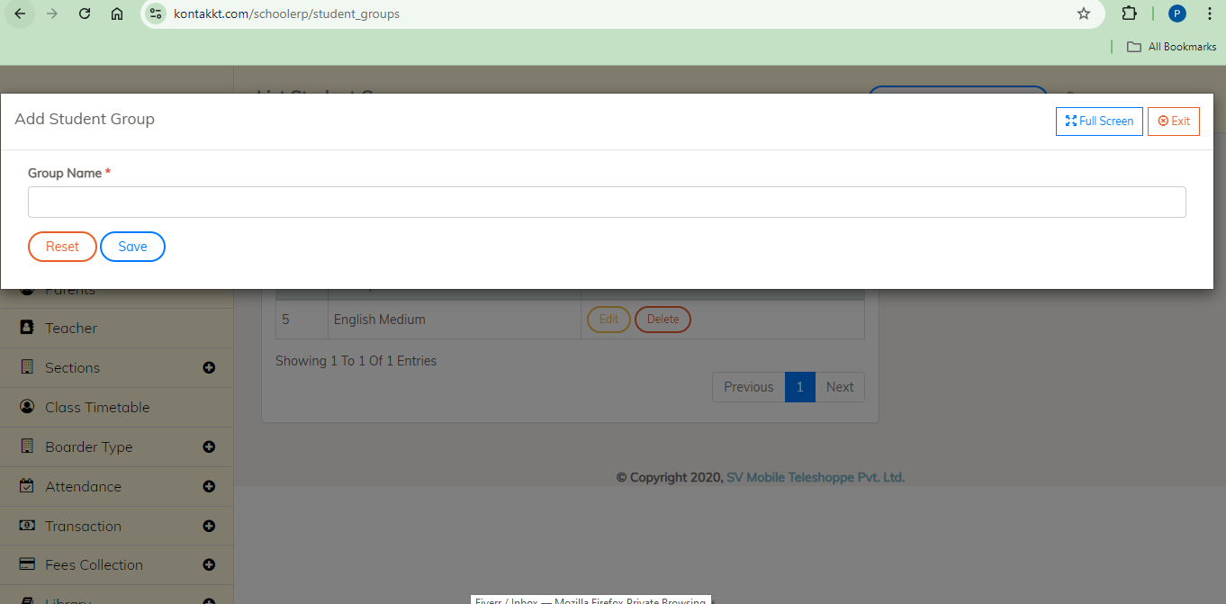

**Q: How do I edit picklist?**  
**A: Click on Administration Section**

1. Click on “Picklist Editor”
2. Click on “Add New”
3. Fill required details
4. Click on “Save

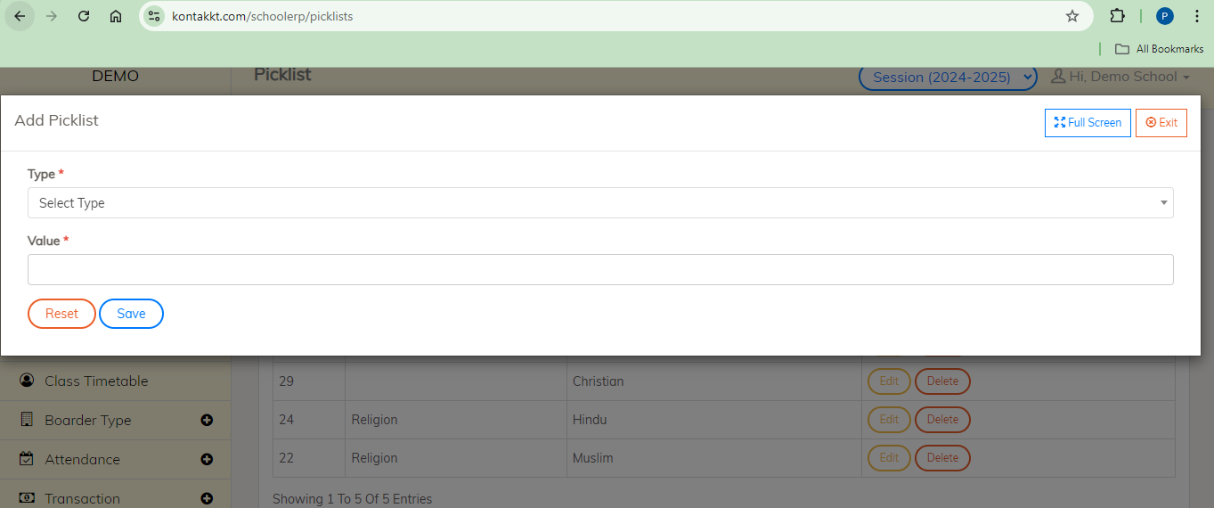

**Q: How do I add role to user?**  
**A: Click on Administration Section**

1. Click on “User Role”
2. Click on “Add New”
3. Fill required details
4. Click on “Save

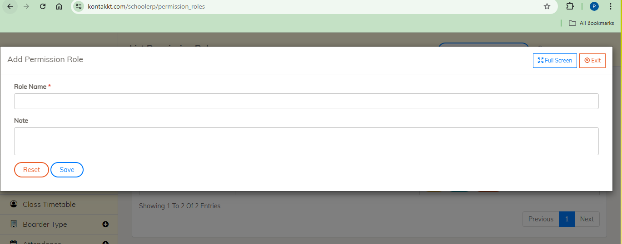

**Q: How can I change permissions to all roles?**  
**A: Click on Administration Section**

1. Click on “Select Permission Role”
2. Select the role required
3. Click on check boxes and select the permissions you want to provide or uncheck if you want to remove permission.
4. Click on “Save Permission”

**Getting Help**

**Q: What if I encounter any issues or need assistance?**  
**A:** If you encounter any issues or need assistance, you can access the help resources by clicking on the "Help" option in the top bar or contacting Kontakkt support.